**TUGAS BASIS DATA**

**FUNCTIONAL DEPENDENCY**



**Nama : MUKHAMAD IKHSANUDIN**

**NIM : 082011633086**

**PROGRAM STUDI S1 SISTEM INFORMASI**

**FAKULTAS SAINS DAN TEKNOLOGI**

**UNIVERSITAS AIRLANGGA**

**2021**

Tugas Teori : Fungsional Dependensi

1. Ujilah dari contoh 2 tabel dibawah ini, tentukan full, partial dan transitive dependency
2. Pecahlah tabel tersebut berdasarkan full dependency.
3. 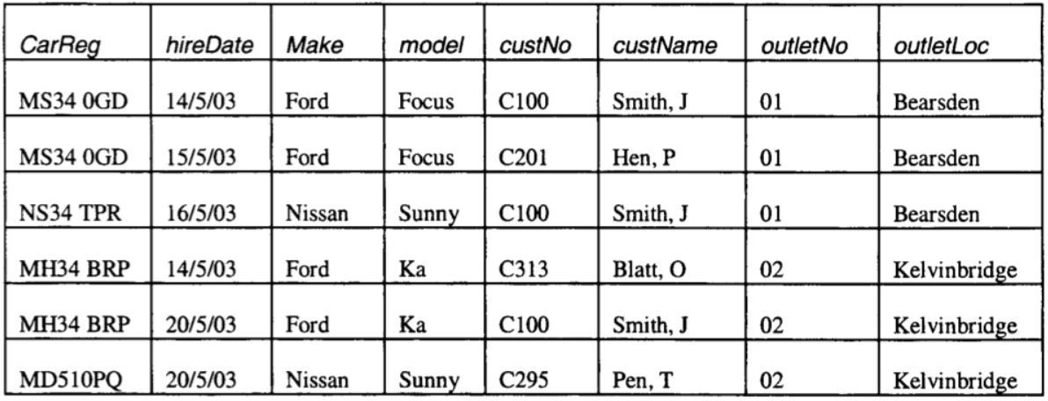Jawaban diupload di Aula dengan nama TugasFD_NIM.pdf Contoh 1

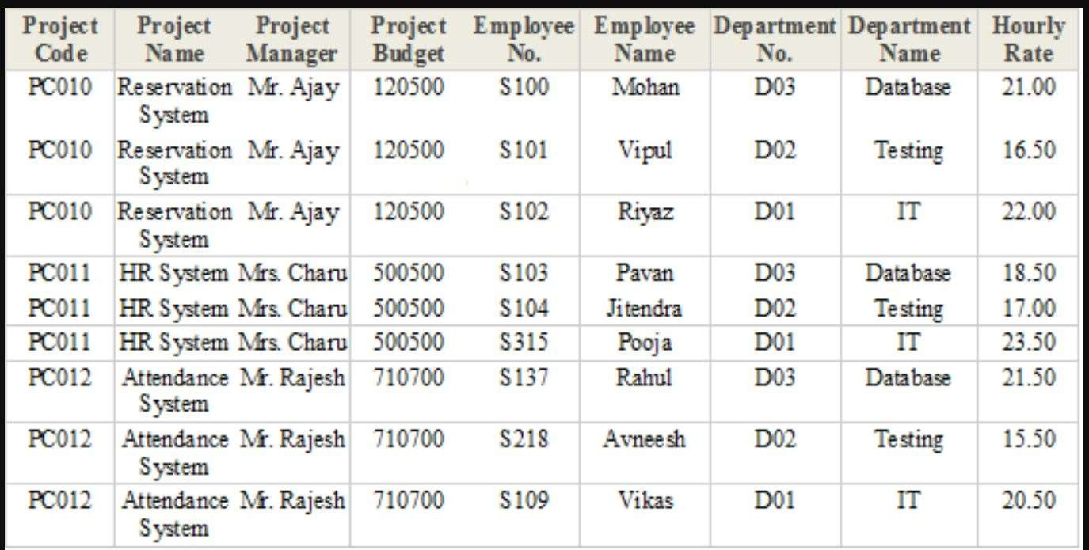Contoh 2

**Tabel 1**

1. a. CarReg, custNo, outletNo $→$ hireDate (Full dependency)

b. custNo $→$ custName (Partial dependency)

c. outletNo $→$ outletLoc (Partial dependency)

d. CarReg $→$ Make, model (Partial dependency)

|  |  |  |  |
| --- | --- | --- | --- |
| **CarReg** | **hireDate** | **custNo** | **outletNo** |
| MS34 0GD | 14/5/03 | C100 | 01 |
| NS34 TPR | 16/5/03 | C100 | 01 |
| MH34 BRP | 14/5/03 | C313 | 02 |
| MD510PQ | 20/5/03 | C295 | 02 |

|  |  |
| --- | --- |
| **custNo** | **custName** |
| C100 | Smith.J |
| C201 | Hen.P |
| C313 | Blatt.O |
| C295 | Pen.T |

|  |  |
| --- | --- |
| **outletNo** | **outletLoc** |
| 01 | Bearsden |
| 02 | Kelvinbridge |

|  |  |  |
| --- | --- | --- |
| **CarReg** | **Make** | **model** |
| MS34 0GD | Ford | Focus |
| NS34 TPR | Nissan | Sunny |
| MH34 BRP | Ford | Ka |
| MD510PQ | Nissan | Sunny |

**Tabel 2**

1. a. Department No $→$ Department Name (Partial dependency)

b. Project Code $→$ Project Name, Project Manager, Project Budget (Partial dependency)

c. Employee No $→$ Employee Name, Departement No, Hourly Rate (Partial dependency)

|  |  |
| --- | --- |
| **Departement No** | **Departement Name** |
| D03 | Database |
| D02 | Testing |
| D01 | IT |

|  |  |  |  |
| --- | --- | --- | --- |
| **Project Code** | **Project Name** | **Project Manager** | **Project Budget** |
| PC010 | Reservation System | Mr.Ajay | 120500 |
| PC011 | HR System | Mrs.Charu | 500500 |
| PC012 | Attendance System | Mr.Rajesh | 710700 |

|  |  |  |  |
| --- | --- | --- | --- |
| **Employee No** | **Employee Name** | **Departement No** | **Hourly Rate** |
| S100 | Mohan | D03 | 21.00 |
| S101 | Vipul | D02 | 16.50 |
| S102 | Riyaz | D01 | 22.00 |
| S103 | Pavan | D03 | 18.50 |
| S104 | Jitendra | D02 | 17.00 |
| S315 | Pooja | D01 | 23.50 |
| S137 | Rahul | D03 | 21.50 |
| S218 | Avneesh | D02 | 15.50 |
| S109 | Vikas | D01 | 20.50 |

|  |  |
| --- | --- |
| **Project Code** | **Employee No** |
| PC010 | S100 |
| PC010 | S101 |
| PC010 | S102 |
| PC011 | S103 |
| PC011 | S104 |
| PC011 | S315 |
| PC012 | S137 |
| PC012 | S218 |
| PC012 | S109 |